Tourism Marketing Certificate
Labor Market Analysis

Labor market data drawn from the LMI database system indicates that there is sufficient demand in Santa Barbara County to support completers of this program. The program supports two labor markets, 1) travel and tourism 2) marketing and sales. The LMI report attached demonstrates the need for this certificate program.

Example job titles for the proposed certificate program and their SOC codes are:

434181 | Reservation and Transportation Ticket Agents and Travel Clerks
397011 | Tour Guides and Escorts
396012 | Concierges
413041 | Travel Agents
397012 | Travel Guides

The number of jobs related to Travel Services and Tourism is expected to remain steady over the next five years. Growth is expected in most areas, most significantly for Concierges (10%) as well as growth on average across the five job titles (4%). The labor market data indicate that there is steadily growing demand for this occupation, with a predicted growth range matching the number of completers expected in the proposed program.

The only job title, which is decreasing is Travel Agents (-1%), which is understandable based on consumer purchasing behavior with online bookings. That said, the LMI data report refers to the concierge job title as a crossover job; indicating that it supports both the tourism industry and the senior living industry. We believe that as baby boomers enter retirement and look for travel experiences, even the Travel Agent job title will see growth as the job market will need to support a less tech-savvy consumer base.

In 2016, there were no regional programs related to the identified occupations for Travel Services and Tourism resulting in 0 annual completions, and 870 annual openings. The related program is Tourism and Travel Services, Marketing Operations (52.1095). This program is career-oriented and there is no similar program of study at SBCC. This program is not available at any colleges that are considered within driving distance. The program has been approved by all California Community Colleges in our region.

The Top Tasks listed in the LMI database align very well with the expected outcomes of the proposed program. Some of the relevant tasks include:
- Sales
- Customer Service
- Upselling products and services
- Product sales
- Industry knowledge

The courses required for this certificate directly correlate with the skills mentioned in the LMI report:

- Consumer Selling Strategies
- Tourism and Hospitality Marketing
- Digital Destination Marketing
- Strategic Positioning in Global Tourism
- Finance for Marketing Budgets
- Marketing Communications

Additional job market information:

The Santa Barbara County WDB reported in 2018 that "the industry clusters providing the largest employment continue to be food, beverage, & agriculture, and tourism & hospitality. These clusters provide 19 percent of all jobs in the county and have increased between 15 and 17 percent since 2010, respectively. This is challenging for the county as these clusters are defined by high tier 3 employment and according to a new national analysis by BW Research are more likely to be impacted by job volatility connected to automation and technology.

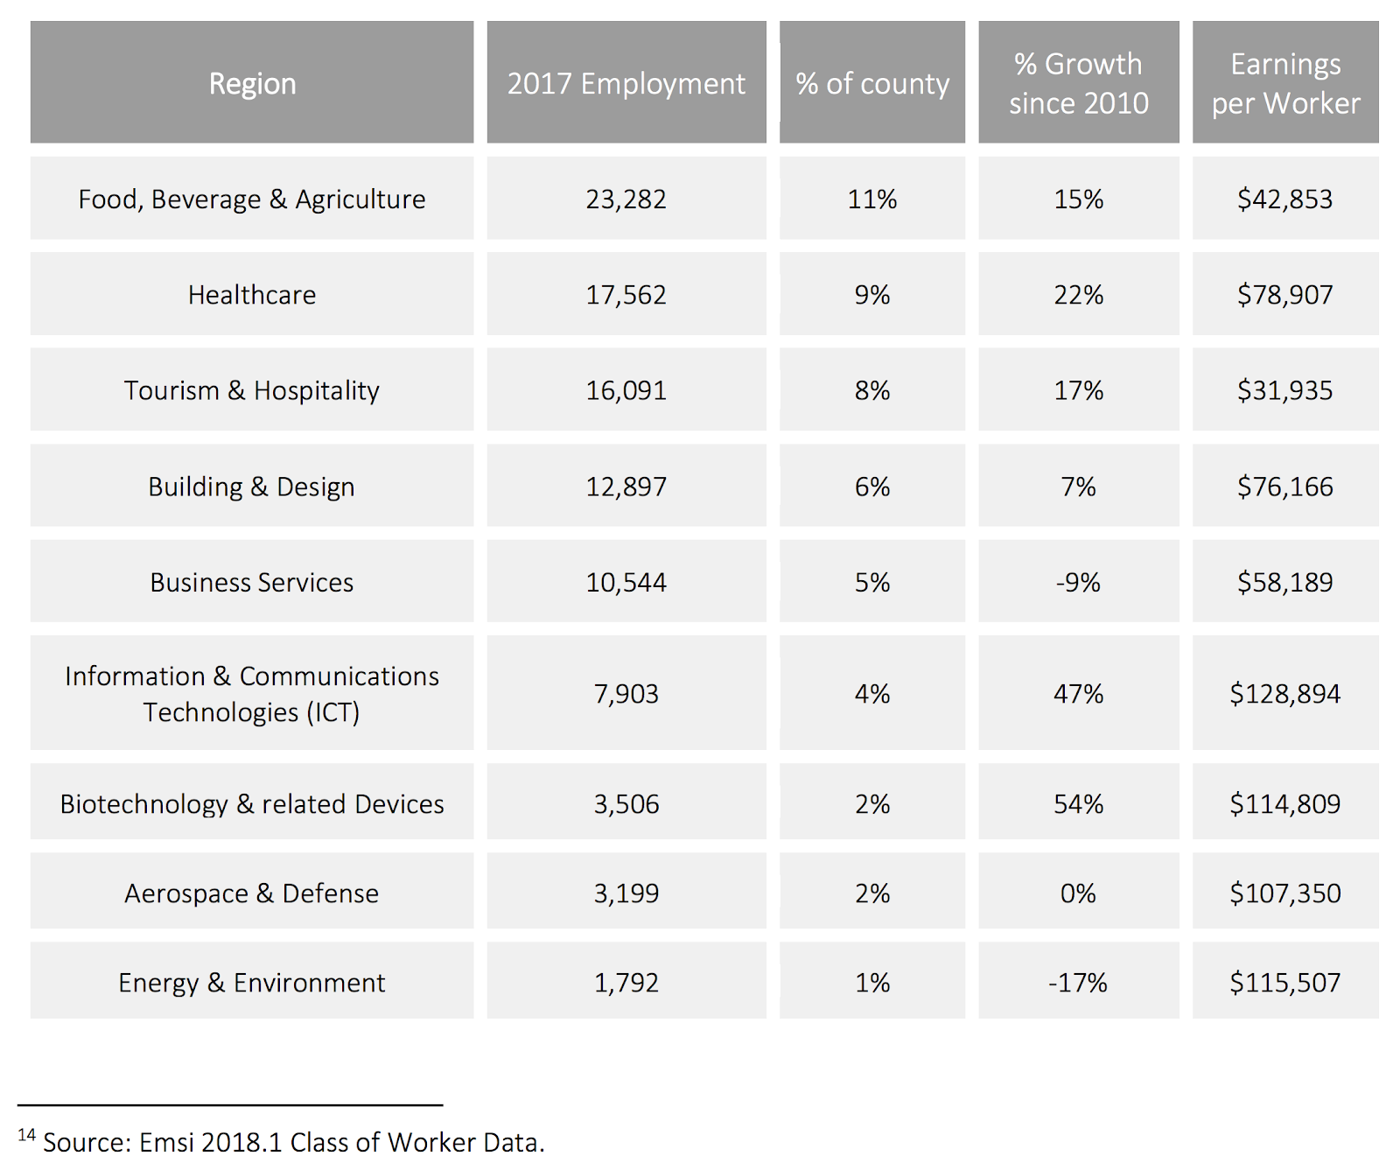
Santa Barbara County Industry Clusters Employment:

The Need for Tier 1 & 2 Occupations

The Santa Barbara (SB) County WDB has reported in 2018 that In Santa Barbara County, over half (52.7%) of the occupations fall in tier 3; 27.7% in tier 2; and 19.8% in tier 1. This distribution has been similar in the past years, with a slight decrease in the tier 1 and tier 2 distribution and an increase in the tier 3 distribution. Job quality represents a critical metric in understanding economic sustainability and tier 3 employment typically does not provide enough income for people to afford to live in Santa Barbara County.

Master Planning: The FIBM Department at SBCC designed and developed this program in order to provide students with an opportunity to satisfy local industry demand for careers within tourism and hospitality marketing. Subsequently, the Department presented the proposed newly-configured certificate program to its Advisory Committee, which strongly supported the development and implementation of the proposed the program, and the department will continue to solicit feedback from its Advisory Committee on an annual basis.

The advisory committee includes:
Joshua Kindervater, CFO Terravant Wine Company
Marie Profant, Founder and CEO of Tours4Mobile
Warren Powers, Regional Manager for Jordanos Food Service
Mo Mojaan, Captain at United Airlines
Carina Powers, FIBM adjunct instructor
Julie Ann Brown, FIBM department chair
Carola Smith, Division Dean

The Advisory Committee has consistently recommended we increase tourism and hospitality content in our current courses and create specialty track certificates.

